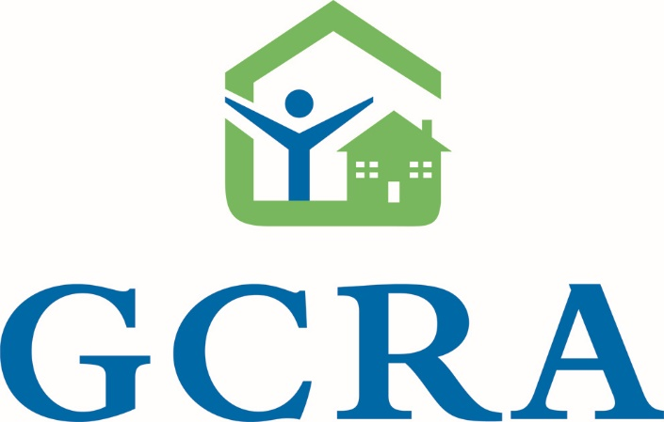
FY 2021 Greenville County
Affordable Housing Funding (GCAHF) and HOME Funding Application

Submission Due Date:
Wednesday, February 17, 2021 at 4:30pm

Training session is on Thursday, January 21, 2021 @ 10 am via zoom. Contact Jose Reynoso jreynoso@gcra-sc.org for zoom access.

APPLICATION SUBMISSION REQUIREMENTS
Complete responses to this application, should include: One (1) printed version of the application with original signatures and one (1) full electronic version with all required attachments, submitted via OneDrive. Email to Jose Reynoso jreynoso@gcra-sc.org on or before 1 pm on February 12, 2021 to receive an upload link. Applications must be submitted electronically and in paper form to:

Greenville County Redevelopment Authority
Attention: Imma Nwobodu, Program Director
301 University Ridge, Suite 2500
Greenville, SC 29607

Telephone: 864-242-9801
www.gcra-sc.org
APPLICATIONS SCORING (100 maximum points)
Application Completeness, Program Eligibility and Site Control 20 points
Maximum points will be awarded for those applications that meet threshold criteria such as program eligibility, site control and completeness.

Consistent with County’s goals, Neighborhood Master Plan, Consolidated Plan and Housing Study report. Address demonstrated need. 20 points
Maximum points will be awarded for those applications that demonstrate sufficient market demand and support the goals and priorities of the Consolidated Plan and the 2018 Greenville County Housing Study report. Appropriateness of site selection are considered, and the design must be consistent with neighborhood design characteristics or master plans.

Financial feasibility. 25 points
Maximum points will be awarded for those applications that contain a realistic set of sources and uses development budget, a pro forma operating budget, and long-term financial sustainability of the project is highly likely.

Development team experience, capacity, project readiness and timeframe for completion. 25 points
Maximum points will be awarded for those applications that demonstrate a development team with a successful track record in projects of similar size, scale, type and complexity to the proposed project and capacity to fulfill their responsibilities and the readiness of the project to proceed.

Neighborhood Impact. 10 points [HOME]
Maximum points will be awarded for those applications where site selection is appropriate for use, the design is consistent with neighborhood design characteristics or master plans, and the project proposes considerable benefits to the neighborhood and/or special populations such as services or amenities.
OR
Income Targeting. 10 points [GCAHF]
Maximum points will be awarded for those applications/projects that specifically target households with fifty (50%) percent or below of the Area Median Income. Projects with the largest percentage of households earning below 50% of the Area Median Income (AMI) will receive the highest score.

Additional Required Documentation | Exhibit Name
Legal name of organization and executive director, type of organization (corporation, limited liability corporation, general partner, etc.), and list of board members including name, position, address, and phone number. | A
Evidence of site control | B
Market Study, discussing demand and need for proposed project. | C
Site plan, building elevations, & photos of building, if applicable | D
Articles of Incorporation, current by-laws, IRS 501 c(3) determination letter | E
Most recent financial statement (independent audit, 990 form, and auditor's management letter) | F
Completed CHDO Certification form [HOME] | G
A brief development team summary, including: List all members of the development team, their role in the project, relevant skills/education and relevant experience from other projects. List and describe projects completed by the organization similar to the proposed project in size, type of development, and complexity. | H
Sources and uses statement, operating budget identifying rents and expenses for first year, & 20 pro forma for the project or minimum affordability period (see financial excel spreadsheet provided) | I
Evidence of financial commitments | J
Marketing plan for the sale of home ownership units, if applicable | K
Funding Allocation

- Gap funding of housing development project or Down payment/Closing Cost Assistance
- No Maximum or Cap allocation
- 10 percent of total funding request will be grant, but not to Not to exceed $100,000
- NON-profit Organization (Rental units projects):
- 1% interest loan amortized for up to 30 years. 1-year payment deferment period during construction.
- Non-profit (Homeownership unit projects ) 1% Interest rate
- For-profit Organization (Rental unit projects) 2% interest loan amortized for up to 30 years. 1 year payment deferment period during construction.
- For-Profit Organization (Homeownership unit projects) 2% interest rate

Affordability Period for HOME & GCAHF projects – Consistent with HOME regulation.

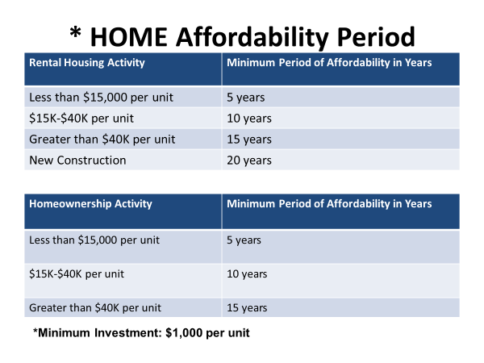

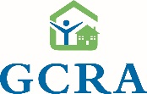
Greenville County Redevelopment Authority
Greenville County, Affordable Housing Fund (GCAHF) and HOME Funding Application

Date:
Applicant/Sponsor:
Executive Officer:
Project Officer:
Address:
City: |  |  |  |  |  | State: |  |  |  |  |  | Zip:
Email:
Phone# |  |  |  |  |  | Phone:
DUNS# |  |  |  |  |  | Tax ID#
Applicant/Sponsor Type (x)
CHDO |  |  |  | Nonprofit Corporation
Municipality |  |  |  | Corporation
General Partnership |  |  |  | Limited Liability Corporation
Joint Venture |  |  |  | Other:
Developer:
Executive Officer:
Primary Contact:
Address:
City: |  |  |  |  |  |  |  | State |  |  |  | Zip
Email:
Phone |  |  |  |  |  |  |  | Fax:
 | Application Type (x):
 | Homeownership |  |  |  | New Construction |  |  |  |  | #Total Units
 | Rental |  |  |  | Rehabilitation |  |  |  |  | #Family Units
 |  |  |  |  | Homebuyer Assistance |  |  |  |  | #Senior Units
 |  |  |  |  |  |  |  |  |  | #Handicap Accessible Units
 |  |  |  |  |  |  |  |  |  | #Other Special Needs

Greenville County Redevelopment Authority
Greenville County, Affordable Housing Fund (GCAHF) and HOME Funding Application

Development Description
Project Name:
Project Address: |  |  |  |  |  | Parcel#
Neighborhood:
Census Tract:
For scattered site projects list addresses and parcels below:
Parcel No. |  |  | Address: |  |  |  |  |  |  | Census Tract:
HOME projects with five or more housing units proposed must provide 20% of the total assisted houses for families with household incomes at 50% or less of AMI and at least 5% of the new housing units must be handicap accessible units. Projects with the largest percentage of households earning below 50% of the Area Median Income (AMI) will receive the highest score.
Income Group |  |  | #Units |  | Unit Type (X):
Less than 30% of AMI |  |  |  |  | Single Family
31-50% of AMI |  |  |  |  | Duplex
51-60% of AMI |  |  |  |  | Tri-plex
61-80% of AMI |  |  |  |  | Townhome
Greater than 80% of AMI |  |  |  |  | Apartment
Funding Request:
Total Development Cost: |  |  |  |  | Total HOME Amount Requested: ___________________________  Total GCAHF Amount Requested: ___________________________
Total Funds Requested:
% of Total Development Cost:
Total Funds Per Unit:

Program Eligibility & Consistent with County’s Goals
Clearly and objectively describe, in narrative form, the entire project you propose to undertake and why. Discuss 1) the goals and objectives of the Greenville County 2020-2024 Consolidated Plan your proposal addresses, 2) project location, housing type, unit description, target population (seniors, disabled, veterans, families etc.) and income groups and income groups and Quantiles identified in the Housing Study that will be served by the project that will be served by the project, 3) all the key steps that must be taken to achieve the project, 4) specific use of HOME and/or GCAHF funds and how the project would not proceed without an investment of the funding. [Attach additional pages as necessary]
Site Control
Does the applicant have site control of property for proposed project?
 | Yes |  | No |  | n/a

 | Deed |  | Option
 | Purchase contract |  | Other:

Expiration date of contract or option: (month, date & year)

Total Cost of land: | $
Parcel (acres) or Building Size (square feet):
Parcel Number (s):
Proposed Property Address:
City: |  | State: |  | Zip Code:
Present zoning classification:
Is a conditional use permit required?
When is approval for it expected?

Are all utilities presently available to the site? |  | Yes |  |  | No
If No, which utilities need to be brought to the site?
Site currently used for:
Prior site uses:

Developer Capacity
Briefly describe your development team. Be sure to list all members of the development team including any consultants, their specific role in the project, relevant skills/education and experience from other projects. List and describe projects completed by the organization similar to the proposed project in size, type of development, and complexity. Show evidence of completion of up to 10 housing units [Attach additional pages if necessary]

Describe special marketing and outreach efforts to be undertaken in order to achieve the affordable housing you propose. Include a list of any minority newspapers, minority oriented radio and television stations and community groups that have significant contact with targeted groups that will be used to market the project. If available, provide a copy of any advertisements, brochures or postcards used to market the project units. Additionally, if Market Study of Need is available, please submit with application.

Neighborhood Impact
Please describe in narrative terms the impact of your proposal upon the neighborhood in which it is located. Does the project propose considerable benefits to the neighborhood and/or special populations such as support services and/or amenities? Does the proposal support economic diversity and integration where all of the units serve low-income households in an area with an AMI above 80 percent. Is the project located within a Greenville County Special Emphasis area or low income census tract? Does it support community master plans or community stability through the infill development and/or quality design?

Project Timeline

 | Proposed Activities | Completion Date
A. | Site Control:
 | Option
 | Site acquisition/Purchase
B. | Financing:
 | 1. Construction loan
 | Conditional commitment
 | Loan closing
 | 2. Permanent loan
 | Conditional commitment
 | Loan closing
C. | Plans and Specifications
 | Preliminary drawings
 | Initial working drawings
 | Working drawings & specifications
D. | Closing and Transfer of Property
E. | Marketing
F. | Construction Starts
G. | Completion of Construction
H. | Lease-up Period | From:
 |  | To:
I. | First Building to be Placed in Service
J. | Last Building to be Placed in Service

Project Name: |  | Applicant Name:

I (Chief Executive Officer)

Name and title

Hereby certify that the information set forth in this application/proposal is, to the best of my knowledge, true and correct. I realize that Greenville County Redevelopment Authority will be relying upon this information and the representations herein as part of their decision-making process in the awarding of funds. Should any information change from that originally submitted, I agree to promptly advise GCRA. I understand that erroneous, misleading or false information can adversely impact funding decisions.

Signature Date

Certification for CHDOs Only [HOME]
Please complete the following checklist, provide back-up documentation as needed, and keep a copy for your records. The questions refer to the definition of a CHDO in Subpart A, Section 92.2 of the HOME Final Rule.

I. LEGAL STATUS
A. The nonprofit organization continues to be organized under State or local laws, as evidenced by:

_____ A Charter, or
_____ Articles of Incorporation

B. No part of its net earnings inure to the benefit of any member, founder, contributor, or individual, as evidenced by:

_____ A Charter, or
_____ Articles of Incorporation

C. Maintains a tax exemption ruling from the Internal Revenue Service (IRS) under Section 501(c) of the Internal Revenue Code of 1986, as evidenced by:
_____ A 501(c) Certificate from the IRS

D. Has among its purposes the provision of decent housing that is affordable to low-and moderate-income people, as evidenced by a statement in the organization's:

_____ Charter,
_____ Articles of Incorporation,
_____ By-laws, or
_____ Resolutions

II. CAPACITY
A. Conforms to the financial accountability standards of Attachment F of OMB Circular A-110, "Standards for Financial Management Systems," as evidenced by:

_____ A notarized statement by the president or CFO of the organization;
_____ A certification from a Certified Public Accountant; or
_____ A HUD approved audit summary

B. Has a demonstrated capacity for carrying out activities assisted with HOME funds, as evidenced by:

_____Resumes and/or statements that describe the experience of paid staff members who have successfully completed projects similar to those to be assisted with HOME funds.
Note: If there has been staff turnover in the Executive Director or Chief Financial Officer positions since the last time the organization was recertified as a CHDO, please submit copies of the new staff resume(s).

III. ORGANIZATIONAL STRUCTURE
A. Maintains at least one-third of its governing board's membership for residents of low-income neighborhoods, other low-income community residents, or elected representatives of low-income neighborhood organizations, as evidenced by the organization's:

_____ By-Laws,
_____ Charter, or
_____ Articles of Incorporation

Board Member Code
 | Qualification Code:
1 | Lives in low-income community
2 | Lives in a low-income household
3 | Elected representative of low-income neighborhood association

Current Board Roster:
Name | Job & Title | State or public official (Y/N) | Home  Address | Low-Income Rep. (Y/N) | Low-income Rep. Qualification
Note: Under the HOME Program, for urban areas the term "community" is defined as one or several neighborhoods, a city, county, or metropolitan area. For rural areas, "community" is defined as one or several neighborhoods, a town, village, county, or multi-county area (but not the whole state).

B. Provides a formal process for low-income, program beneficiaries to advise the organization in all of its decisions regarding the design, siting, development, and management of all HOME-assisted affordable housing projects, as evidenced by:
_____ The organization's By-laws,
_____ Resolutions, or
_____ A written statement of operating procedures approved by the governing body.
C. A CHDO may not be a governmental entity and must not be controlled by a governmental entity. If the CHDO was created by a governmental entity, however, the State or local government may not have the right to appoint: (1) more than one-third of the membership of the organization's governing body; (2) the board members appointed by the State or local government may not, in turn, appoint the remaining two-thirds of the board members; (3) no more than one-third of the governing board members are public officials or employees of the governmental entity; and (4) the officers or employees of the governmental entity may not be officers or employees of the CHDO, as evidenced by the organization's:
_____ By-Laws,
_____ Charter, or
_____ Articles of Incorporation
_____ Not applicable
D. If the CHDO is sponsored or created by a for-profit entity, the for-profit entity may not appoint more than one-third of the membership of the CHDO's governing body and the board members appointed by the for-profit entity may not, in turn, appoint the remaining two-thirds of the board members, as evidenced by the CHDO's:
_____ By-Laws,
_____ Charter, or
_____ Articles of Incorporation
_____ Not applicable

IV. RELATIONSHIP WITH FOR-PROFIT ENTITIES
A. CHDO is not controlled, nor receives directions from individuals or entities seeking profit from the organization, as evidenced by:

_____ The organization's By-laws, or
_____ A Memorandum of Understanding (MOU)
B. A CHDO may be sponsored or created by a for-profit entity, however, if:

(1) The for-profit entity's primary purpose does not include the development or management of housing, as evidenced by:
_____ The for-profit organization's By-laws,
_____ Not applicable
(2) The CHDO is free to contract for goods and services from vendor(s) of its own choosing, and
(3) The officers and employees of the for-profit entity may not be officers or employees of the CHDO,
as evidenced by the CHDO's:
_____ By-Laws,
_____ Charter, or
_____ Articles of Incorporation
_____ Not applicable

We certify that the information provided herein is accurate, and that to the best of our knowledge, the:

__________________________________
(name of organization)

continues to comply with all requirements to be considered a Community Housing Development Organization as described in 24 CFR 92.2.

_________________________________ ____________________________ _________
Signature of Board President (or Chair) Name (please print) Date
________________________________ ____________________________ _________
Signature of Executive Director Name (please print) Date

